ANP-D3569
StudentID: AF05093353
Name: BAVIGADDA SUSMITHA

Database Design for
Online Blood Donation System
ONLINE BLOOD DONATION SYSTEM
An Online Blood Donation System is a software application designed to connect blood donors, recipients, and blood banks efficiently. The main objective of this system is to ensure quick and easy access to blood during emergencies, maintain donor records, and streamline donation processes.
This system helps users register as donors, search for available blood groups, request blood, and manage donation history. Blood banks can monitor inventory levels, approve requests, and track donations. It improves communication between donors and recipients and ensures timely availability of blood.
Designing a database for an Online Blood Donation System includes identifying entities, their attributes, and relationships.

Entities:
- donor
- recipient
- blood_bank
- blood_request
- donation
- blood_inventory

Entity-Relationships:
- A donor can donate blood multiple times, but each donation is linked to one donor → (One-to-Many)
- A recipient can request blood multiple times, but each request belongs to one recipient → (One-to-Many)
- A blood_bank manages multiple blood inventories and handles many donations → (One-to-Many)
- A blood_request is fulfilled by one blood bank, but a blood bank can handle multiple requests → (One-to-Many)
- A donation updates the blood inventory, and one donation corresponds to one blood bank → (One-to-Many)
- Blood inventory contains different blood groups, and each blood bank maintains multiple blood group records → (One-to-Many)

Attributes:
donor
- id
- name
- age
- gender
- blood_group
- contact_number
- address
- last_donation_date
- email

recipient
- id
- name
- blood_group
- contact_number
- address

blood_bank
- id
- name
- location
- contact_number

blood_request
- id
- recipient_id
- blood_group
- request_date
- status

donation
- id
- donor_id
- blood_bank_id
- donation_date
- quantity

blood_inventory
- id
- blood_bank_id
- blood_group
- quantity

Entity: health_check
Attributes:
- id
- donor_id
- check_date
- weight
- blood_pressure
- hemoglobin_level
- is_alcoholic (Yes/No)
- is_smoker (Yes/No)
- has_disease (Yes/No)
- disease_details
- is_eligible (Yes/No)

ENTITY RELATIONSHIP DIAGRAM - ONLINE BLOOD DONATION SYSTEM
(You can draw ER diagram using these relationships)
- Donor → Donation → Blood Bank
- Recipient → Blood Request → Blood Bank
- Blood Bank → Blood Inventory
Online Blood Donation System – Overall Points
- Online Blood Donation System is developed using Java, SQL, JDBC, and Hibernate
- The main purpose is to connect donors, recipients, and blood banks
- It helps in quick blood availability during emergencies
- The system allows donor registration and stores their details
- It includes a health check module to verify donor eligibility (alcohol, smoking, diseases)
- Donors can donate blood if they are eligible
- Blood banks store and manage blood inventory
- Recipients can request blood based on their requirement
- The system checks blood availability and processes the request
- All data is stored in a relational database using SQL
- Tables used: donor, recipient, blood_bank, donation, blood_request, blood_inventory, health_check
- Relationships are maintained using primary keys and foreign keys
- The system reduces manual work and saves time
- It provides accurate and fast data management
- Overall, this system helps in saving lives by making blood access easier and faster

ENTITY RELATIONSHIP DIAGRAM -Online Blood Donation System
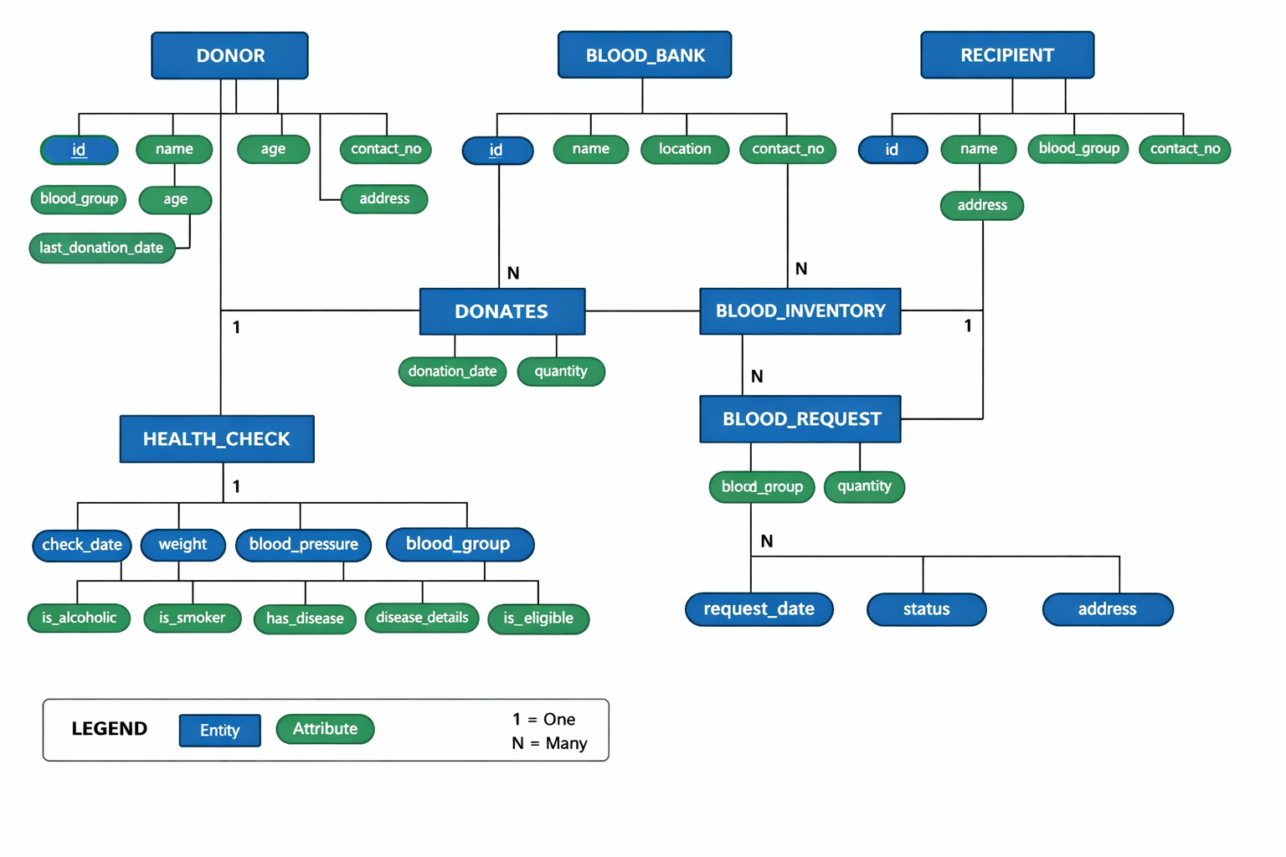

ER - Online Blood Donation System
